About YUEDU Shredders
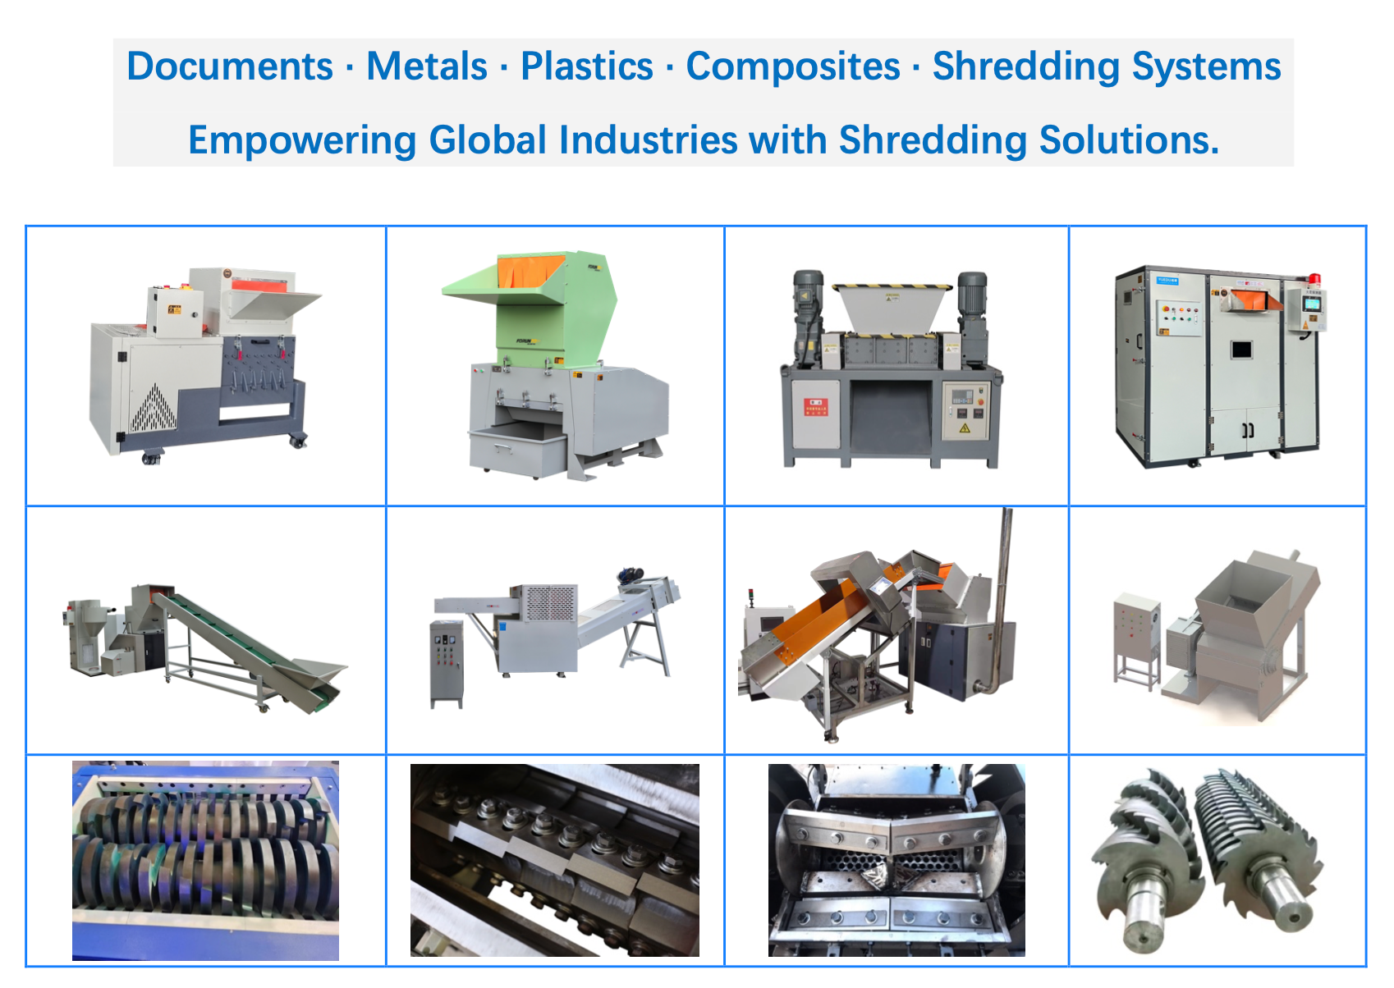

Company Profile
Shanghai YUEDU Technology Co., Ltd. is a Shanghai-certified high-tech enterprise specializing in the development and manufacturing of shredding and destruction equipment. We serve a wide range of sectors including government agencies, financial institutions, military departments, enterprises, and recycling industries.
Our offerings include office and industrial-grade paper shredders, hard drive destroyers, plastic crushing systems, and fully customized destruction center solutions. From design to delivery, we help clients achieve efficient, secure, and compliant material destruction.
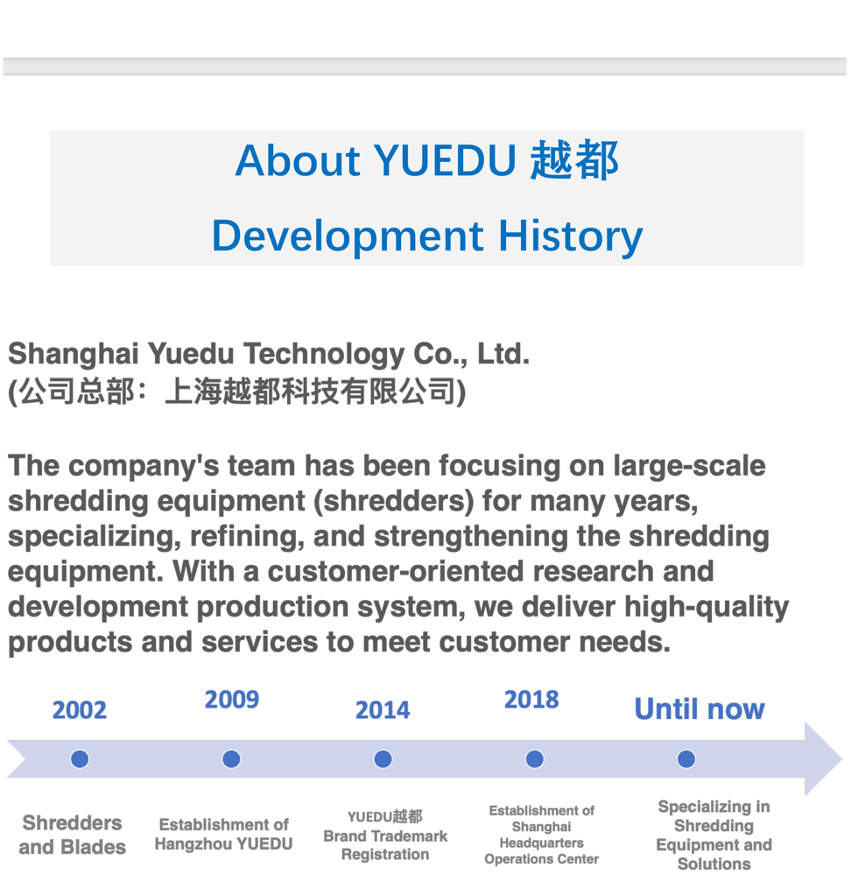

Company History & Milestones
Company History
Founded in 2002:
YUEDU began its journey with the OEM manufacturing of shredding machines and blades, primarily focused on international exports. Our mission was clear from the start — to provide high-quality products that solve clients' material destruction needs.
2009 - Establishment of Hangzhou Yuedu:
In 2009, we expanded our operations and established Hangzhou Yuedu, officially entering the Chinese market. We launched the YUEDUbrand of shredders, offering locally manufactured, high-quality solutions to meet the growing demand for efficient document destruction across the country.
2018 - Shanghai Headquarters:
In 2018, we established our Shanghai Yuedu Technology Co., Ltd., which now serves as the operational and innovation hub for our products and solutions. This marks the foundation of our global expansion strategy, enabling us to serve customers worldwide more effectively.
2019 - Establishment of Shanghai Crushing Equipment R&D Center:
To meet the increasing demand for innovative and high-performance shredding solutions, in 2019, we founded the Shanghai Crushing Equipment R&D Center. This center focuses on cutting-edge research and development, ensuring that we remain at the forefront of the industry in terms of technology and product advancements.
2024 - Launch of Hangzhou Xiaoshan R&D Center:
In 2024, we expanded our innovation capabilities further by opening the Hangzhou Xiaoshan R&D Center, dedicated to the research and development of new shredding and crushing technologies. This facility enables us to speed up product development and better meet the specialized needs of our global customers.

Milestones & Key Developments:
• 2014: YUEDU trademark officially registered.
• 2015: Introduction of high-security document destruction systems, leading to large-scale contracts with government and military clients.
• 2018: Opening of Shanghai headquarters, enabling more efficient production and logistics for global customers.
• 2022: Launch of 1mm powder-level shredders, setting a new industry standard in document and media destruction.
• 2024: Expanding product line to include plastic shredders and custom crushing systems, strengthening our market presence globally.
Future Vision:
• YUEDU is committed to becoming a global leader in the shredding and crushing industry. Our vision is to continuously evolve our solutions to meet the ever-growing demands of our customers worldwide.
• Leveraging our years of expertise in China, we plan to serve more customers in niche industries, helping them achieve customized material destruction solutions.
• Long-Term Focus: As we expand, we continue to prioritize innovation, quality, and customer-centricity, ensuring our technology and services are always aligned with the latest industry trends and customer needs.
Our Brand Story:
Shanghai Yuedu Technology Co., Ltd., under the YUEDU brand, has always been focused on providing cutting-edge shredding solutions. Over the years, our dedication to making powerful, precise, and reliable equipment has positioned us as a trusted partner for industries worldwide.

Future Outlook:
• Continue to focus on the research, development, and manufacturing of shredding equipment, further expanding our influence in the global market.
• Innovative Development: We will continue to develop more efficient, environmentally friendly, and intelligent shredding systems to meet the customized needs of clients across various industries.
• Serving Global Clients: Our goal is to apply the technological expertise accumulated in China to global markets, solving specific shredding needs for customers and helping them improve efficiency, reduce costs, and ensure compliance.

Our Mission:
We are dedicated to the shredding industry, continuously solving various material destruction and shredding needs for our clients.
Our Values:
• Learn business philosophy from Warren Buffett, Charlie Munger, and Duan Yongping.
• Build an operation system driven by user needs, rather than sales-driven.
• Uphold long-termism, avoiding short-term profits.
• Advocate for integrity in both business and personal conduct.
• Make decisions based on common sense and customer value, aiming for simple, effective, and practical solutions.

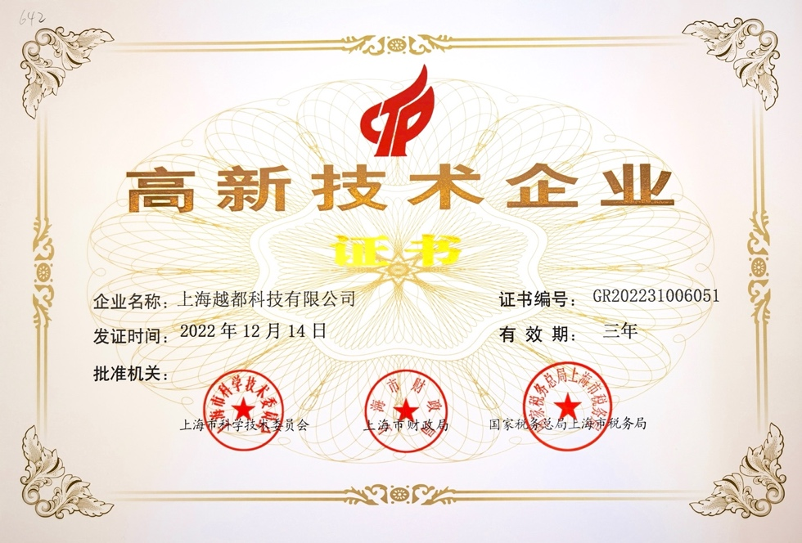

✅ International Certifications
- ✅ EU CE Certification
Ensures compliance with EU health, safety, and environmental protection standards, enabling product access to the European market.
- 📋 ISO Quality Management System Certification
Demonstrates standardized internal processes, consistent product quality, and excellence in customer service.

✅ Export & Industry Certifications
- 🌐 Customs Export Qualification / Import-Export License
Confirms our legal status and capabilities for international trade and customs clearance.
- 🛡 Government Procurement / Military Approved Supplier Certificate
Demonstrates our compliance and experience in supplying secure, high-standard equipment to government agencies and military departments.
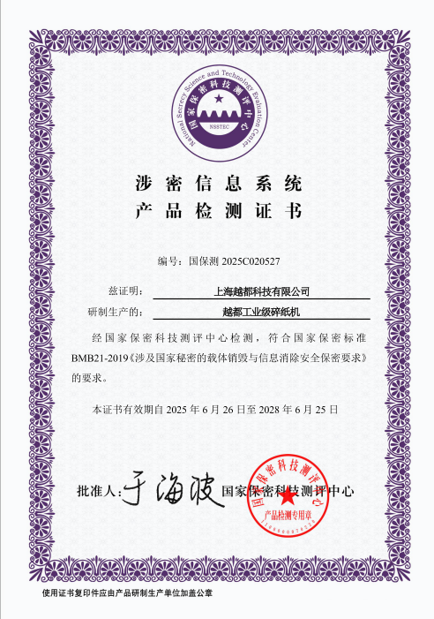

🧑‍💼 CEO Message
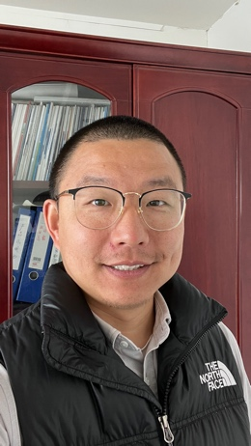
Dear Partners,
Welcome to YUEDU!
Since our founding, YUEDU has had a singular mission: to deliver secure, efficient, and customized shredding solutions that truly solve the challenges our clients face. We’ve always placed our focus on solving the real problems of our clients, and it is this unwavering commitment to understanding their needs and delivering value that has been key to our success.
As a company, we draw inspiration from the great minds of industry leaders such as Warren Buffett, Charlie Munger, and Duan Yongping. We are building a demand-driven organization, grounded in long-term thinking, integrity, and practical wisdom.
I firmly believe that good business is not just about selling products; it’s about fostering trust, nurturing partnerships, and consistently providing real value. Each solution we offer is designed to have a profound impact on our clients’ security, privacy, and future-proofing.
I want to take this opportunity to express my deep gratitude to all our partners and clients for the trust you’ve placed in us. Together, we will continue to grow, innovate, and stay true to our mission of delivering excellence.
Thank you for being a part of YUEDU’s journey. We are excited to continue working with you, pushing the boundaries of what we can achieve together.
Hao Deng
CEO & Founder
Shanghai YUEDU Technology Co., Ltd.
Email: denghao8410@gmail.com

📞 Contact Us

Johnny Deng, Managing Director
☎️ Phone: +86 159 0178 2779 (WhatsApp / WeChat / Facebook / Telegram)
📧Email: denghao8410@gmail.com

Shanghai YUEDU Technology Co., Ltd. (YUEDU Shredders)
🌐 Website(Global): www.yuedushredders.com (note: VPN required for China access, as the server is hosted by Google.)
📧 Email: yuedushredders@gmail.com / denghao8410@gmail.com
☎️ Sales Supervisor: +86 159 0178 2779 (WhatsApp / WeChat / Facebook / Telegram) ☎️ Administrative Supervisor: +86 137 6138 5116
☎️ Head Office Main Line: +86 21 519 000 20
📍 Company Headquarters: Building 12, No. 555 Chengyin Road, Baoshan City Industrial Park, Shanghai, China

